**Counting number of printf and scanf in a string**

Program:

%{

#include<stdio.h>

#include<stdlib.h>

int p = 0, s = 0;

%}

%%

(printf) p++;

(scanf) s++;

%%

int main()

{

printf("Enter a string\n");

yylex();

printf("printf count = %d\nscanf count = %d",p,s);

}

Output:

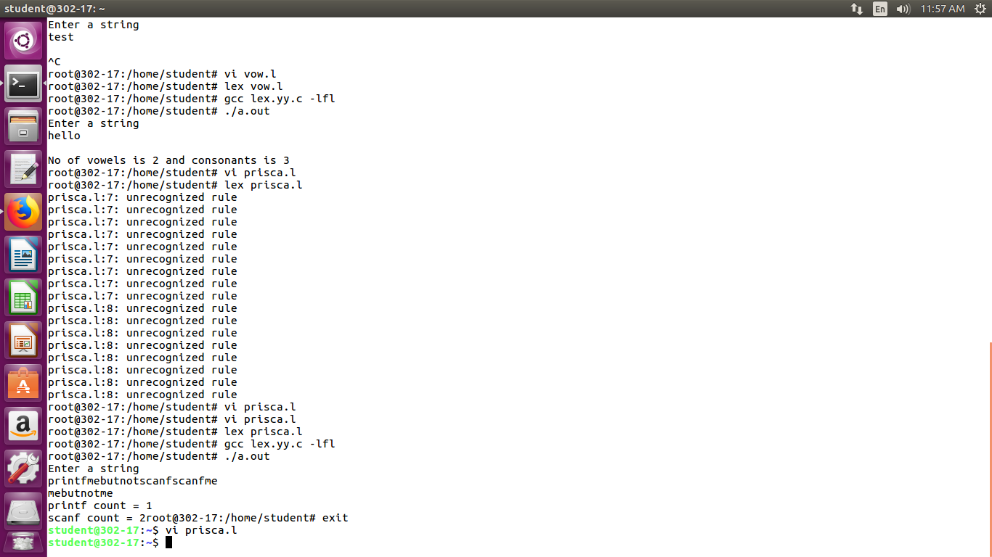

**Count number of adverb adjective and verb in grammar**

Program:

%{

#include<stdio.h>

#include<stdlib.h>

int adv = 0, adj = 0, verb = 0;

%}

%%

(easily) adv++;

(lazy) adj++;

(runs) verb++;

%%

int main()

{

printf("Enter a string\n");

yylex();

printf("adjective count = %d\nadverb count = %d\nverb count = %d",adj,adv,verb);

}

Output:

